Departement of te English Language
Module:Civilisation
Level:l 1
Time Alloted:1:30
TeacherProf.
RAOUTI Rabha
Title of Lesson:Norman Conquest
Semester 1

Aims:
- Introduce the Norman Conquest: Explain the historical significance of the Norman invasion of England in 1066.
- Explore Rivalries for the Throne: Provide an overview of the key contenders for the English throne and the events leading up to William’s victory.
- Examine the Conquest’s Impact: Analyze how the Norman Conquest transformed England politically, socially, and economically.
- Highlight the Wider European Context: Show how the conquest strengthened Norman influence and altered the balance of power in Europe.

Objectives:
- Detail Key Figures and Battles: Identify the main rivals for the throne and describe their roles in the Battle of Hastings and related events.
- Explain William’s Ascension: Discuss William’s coronation and the methods he used to consolidate power, including the 'Harrying of the North.'
- Analyze Societal Changes: Illustrate the shift in power dynamics, including the Saxons’ subjugation and the establishment of a feudal system.
- Examine Long-Term Effects: Highlight the lasting cultural, economic, and political impacts of the Norman Conquest on England and Europe.
- Explore Military Strategy: Outline the tactics and strategies that led to Norman success in securing control over England.
This text aims to provide a concise yet comprehensive understanding of the Norman Conquest, focusing on the causes, key events, and profound effects it had on English and European history.

Unit 5
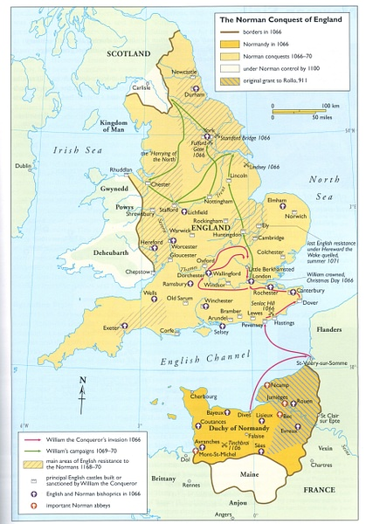
Map of the Norman Conquest of England (Illustration) - World ...
www.worldhistory.org

Text Norman Conquest
England was successfully invaded by a Norman army from France in 1066. This is one of the most well-known dates in English history. What happened, and why, and what was the impact of the invasion?
Throne Rivalry
The three main rivals for the throne were: Harold Godwinson, arald Hardrada,William of Normandy. When Edward the Confessor died, Harold Godwinson, Earl of Wessex, was immediately crowned king and became Harold II. The royal council, known as the Witan, supported him. He gathered an army to defend the kingdom.
Edgar Ethling was Edward’s closest direct relative, but this was a distant connection as he was Edward’s father’s grandson by his first marriage. Edgar was weak and lacked credibility due to being a child in exile in Hungary.
Harald Hardrada was king of Norway. He invaded Yorkshire with a fleet of ships, but was defeated and killed by Harold's army at the Battle of Stamford Bridge.While Harold II was in the north of England fighting Hardrada, William, Duke of Normandy invaded Sussex. Harold rushed back south to fight him. On 14 October 1066, Harold II fought William's army at the Battle of Hastings and lost. Harold was killed.
The Crowning of William
William was crowned king of England on Christmas Day 1066, but it took years more fighting to conquer the whole country. His cruellest campaign was the 'Harrying of the North' in 1069, where he slaughtered the inhabitants of the north-east and destroyed their food stores so that even the survivors starved to death.
The Impact of Norman Conquest
The Norman Conquest changed the face of England forever. William ruled as unquestioned conqueror and the Saxons became merely an unpaid workforce for their new lords.The Norman Conquest also changed the history of Europe – adding the wealth of England to the military might of Normandy made the joint-kingdom a European super-power.
Exercise One : Read the first paragraph complete the table
what | Where | when | What for

Exercise Two :Read the second paragraph and say if the statements are true or false
1-There was no rivalry for acquiring the British throne from any part.
2- Harold Godwinson was crowned king not until the death of William the Confesor
3- The Witan rejected Harold’s crowning and fought against him.
4- Edgar Ethling was a true heir, however, he could not have access to the Bitish thone.
5.- Norway’s king Hardrada failed to invade Yorkshire.
6- Harold II could not stand in the face of William ,King of Normandy.
7- The Battle of Hastings marked the end of Harold II and the begining of the Norman conquest.
Exercise Three: Read and answer the questions below
1- Was it easy for William the Conquerer to subdue the whole country ? explain ?
………………………………………………………………………………………………………………………………………………………………………………

2- What impact did the Normans have either on Britain or on Europe as a continent ? Give illustrations ?
………………………………………………………………………………………………………………………………………………………………………………
3-What type of ruler was William ?Answer using your own words and illustrate for your answer ?
………………………………………………………………………………………………………………………………………………………………………………

