Departement of te English Language
Module:Civilisation
Level:l 1
Time Alloted:1:30
TeacherProf.
RAOUTI Rabha
Title of Lesson:
Anglo Saxons
Semester 1

Aims:
- Introduce Anglo-Saxon History: Provide an understanding of the Anglo-Saxon period in Britain, from the end of Roman rule to the Norman Conquest.
- Highlight Cultural Evolution: Explore the development of Anglo-Saxon society, religion, language, and literature.
- Examine Viking Influence: Detail the interactions between Anglo-Saxons and Vikings, including conflicts and cultural exchange.
- Discuss Historical Transition: Trace the changes in governance and society leading to the Norman Conquest and its impact.

Objectives:
- Explain the End of Roman Britain: Describe how Roman withdrawal left Britain vulnerable to external influences.
- Discuss Anglo-Saxon Migration and Kingdoms: Analyze the formation of Anglo-Saxon kingdoms and their cultural integration with local populations.
- Explore Anglo-Saxon Religion: Compare the transition from paganism to Christianity and its effects on society.
- Detail Linguistic Contributions: Highlight the significance of Old English and key literary works like Beowulf and The Anglo-Saxon Chronicle.
- Describe Viking Interactions: Explain Viking raids, settlements, and their impact on Anglo-Saxon England.
- Understand the Norman Conquest: Examine the events leading to the Norman Conquest, including the Battle of Hastings and the establishment of Norman rule.
This text aims to provide a comprehensive overview of the Anglo-Saxon era, focusing on cultural, religious, and political developments, while emphasizing key historical events that shaped early

Unit 4 The Anglo Saxons

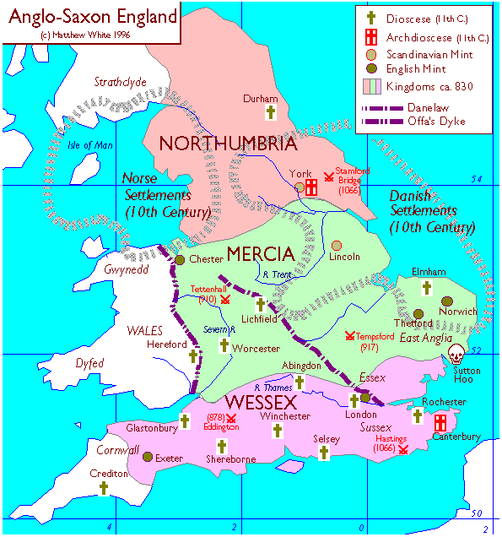
Anglo-Saxon England · Mediterranean 900AD · Southern England circa ...
www.pinterest.com

Text Anglo- saxons
The end of Roman Britain
The Roman legions began to withdraw from Britain at the end of the fourth century to protect other areas of the empire from invading forces. Then, in AD 410, a letter from the Emperor Honorius told the towns of Britain to organize their own defences from that time on.Germanic people in Britain
During the Roman period, Germanic auxiliary troops had formed part of the army and their presence in Roman Britain would have facilitated any migration of peoples from the Germanic areas of mainland Europe. Graves and settlements suggest that the British population was not killed or displaced, but instead came to adopt Anglo-Saxon culture. The extent of Anglo-Saxon migration seems to have differed considerably across England. Gradually, the different Germanic peoples formed unified cultural and political groups and a number of Anglo-Saxon kingdoms developed, finally unifying into the kingdom of England in the 10th century.
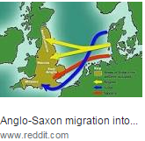
Anglo-Saxon religion : Early Anglo-Saxon religion was a pagan belief system based on Germanic mythology.
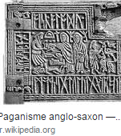

Remnants of these gods remain in the English names for the days of the week: Tuesday - Tiw (god of war), Wednesday - Woden (god of the dead), Thursday – Thor (god of thunder) and Friday - Fréo (goddess of love). In AD 597, St. Augustine was sent to England by Pope Gregory (the head of the Roman Christian church) to convert the Saxons to Christianity.
Augustine landed in Kent and converted King Aethelbert of Kent and his court to Christianity and founded a monastery at Canterbury. Christianity gradually spread across England replacing the Anglo-Saxon pagan religion.
Anglo-Saxon language :Old English was the language spoken until the Norman Conquest of AD 1066 when,influenced by the Anglo-Norman language spoken by the ruling class, it gradually changed into Middle English. Before literacy in Old English or Latin became widespread, Runes were used for inscriptions. Anglo-Saxon literature included epic poetry, sermons, Bible translations, legal works, chronicles and riddles. Famous works include the poem Beowulf and The Anglo-Saxon Chronicle – a collection of writing important for early English history.
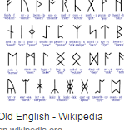
The Vikings :The term Viking covers the pagan peoples of Scandinavia who spoke Old Norse, a Germanic language spoken by inhabitants of Scandinavia and their overseas settlements until about AD 1300. The Vikings were mainly farmers, fishers, hunters and skilled craft workers. Many Vikings traded with Europe, Russia and Asia, exchanging furs, walrus ivory, amber and slaves for silver, gold and luxury goods including wine, fine textiles, pottery and glassware. In AD 793 Vikings raid the monastery on Lindisfarne. This marked the beginning of a period of raids on the British Isles. Later, restricted by a lack of natural resources and land, some Vikings migrated overseas to Britain in search of better land to farm.
Vikings in Britain : During the ninth century, Danish Vikings settled in eastern England. From AD 870 they moved west and invaded Wessex in AD 878. King Alfred of Wessex defeated them in battle and established a frontier dividing England in two. The north and east came under Danish control (Danelaw) while Alfred controlled West Mercia, Kent and Wessex.
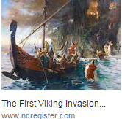
The end of Anglo-Saxon England :When King Edward died in January 1066, he was succeeded by the last Anglo-Saxon king, Harold II. William, Duke of Normandy, (a distant cousin of Harold) said that Edward had promised him the throne and crossed the Channel with an army to claim it. William’s army defeated Harold at the Battle of Senlac (near Hastings) on 14 October 1066 and was rowned king in Westminster Abbey on Christmas Day. To help rule his new kingdom he built over 80 stone castles, redistributed land among his Norman supporters and in AD 1085 ordered a survey of land ownership which was recorded in the Domesday Book
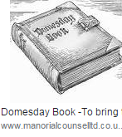

Exercise One :Read the first paragraph complete the table

what | Where | when | What for

Exercise Two :read paragraph two and say true or false
1- The Romans did not accept soldiers of Germanic descent.
2- Germanic people found it difficult to immigrate to Britain during the Roman period.
3- British population was not wellcomed by Anglo saxons
4- Anglo Saxons formed the kingdom of England after unification in the 10 th century.
Exercise Three: Read paragraph three and complete the table below
Word | Definition
1- Pagan  2- Remnants  3- monastery  4- mythology  5- runes | a-  b-  c-  d-  c-

Exercise Four: Read paragraph three and answer the questions below
1 -What type of english was spoken until the Roman Conquest ?
………………………………………………………………………………………………………………………………………………………………………………
2- How did language develop ?
………………………………………………………………………………………………………………………………………………………………………………
3-What language was used prior to Old English and Latin ?
………………………………………………………………………………………………………………………………………………………………………………
4 - whad did Anglo-Saxon literature contain ?
………………………………………………………………………………………………………………………………………………………………………………

