Departement of te English Language
Module:Civilisation
Level:l 1
Time Alloted:1:30
TeacherProf.
RAOUTI Rabha
Title of Lesson: Roman Invasion
Semester 1

Aims:
- Provide Historical Context: Introduce the Roman occupation of Britain and its impact on British society, culture, and governance.
- Highlight Roman Contributions: Showcase the advancements brought by the Romans, such as literacy, infrastructure, and military organization.
- Examine Cultural Interactions: Explore the interactions between Romans and Celts, including conflict and cultural exchange.
- Discuss the Decline of Roman Britain: Explain the factors leading to the collapse of Roman control and its aftermath.

Objectives:
- Explain the Motivation for Invasion: Clarify why the Romans invaded Britain, including economic and strategic reasons.
- Outline Roman Influence: Discuss how Roman practices, such as literacy and urbanization, shaped Britain.
- Describe Military Efforts: Highlight the Roman military’s success in southern Britain and its challenges in conquering Scotland.
- Discuss Hadrian’s Wall: Explain its significance as both a defensive structure and a historical border marker.
- Analyze the Collapse: Identify the internal and external pressures that led to the end of Roman rule in Britain.
- Explore Post-Roman Legacy: Examine the transition from Roman Britain to the arrival of Anglo-Saxon culture.
This text aims to provide a comprehensive understanding of the Roman era in Britain, emphasizing its transformative effects on society, its challenges, and its lasting historical legacy.
Unit 03 The Romans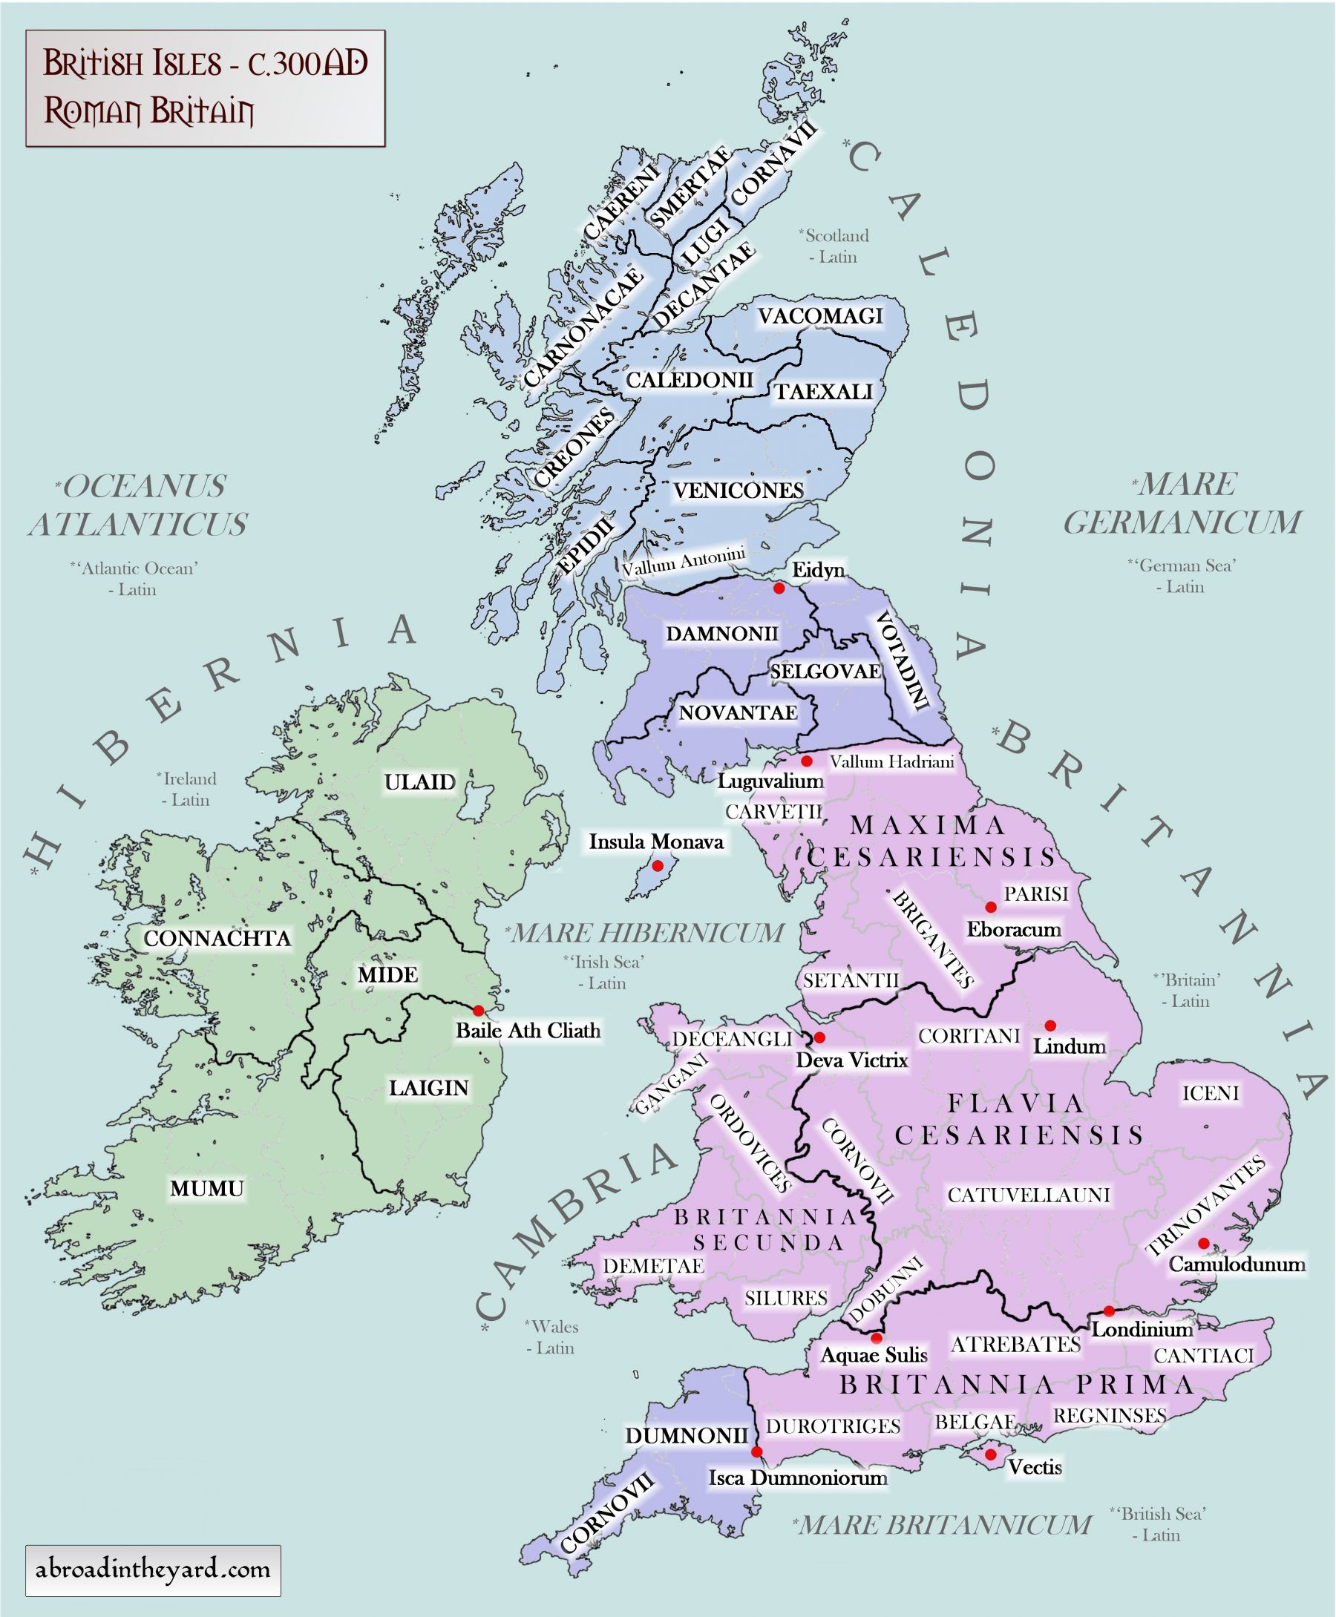
Maps of Britain and Ireland's ancient tribes, kingdoms and DNA ...
www.pinterest.com

Text
Roman Britain
The name "Britain" comes from the word "Pretani ", the Greco-Rornan word for the inhabitants of Britain. The Romans mispronounced the word and called the island "Britannia". The Romans had invaded because the Celts of Britain were working with the Celts of Gaul against them. The British Celts were giving them food, and allowing them to hide in Britain. There was another reason . The Celts used cattle to pull their ploughs and this meant that richer, heavier land could be farmed. Under the Celts Britain had become an important food producer because of its mild climate . It exported corn and animals, as well as hunting dogs and slaves, to the European mainland.
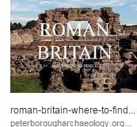
The Romans could make use of British food for their own army fighting the Gauls. The Romans brought the skills of reading and writing to Britain. The written word was important for spreading ideas and also for establishing power. While the Celtic peasantry remained illiterate and only Celtic speaking, a number of town dwellers spoke Latin and Greek with ease, and the richer landowners in the country almost certainly used Latin. But Latin completely disappeared both in its spoken and written forms when the Anglo-Saxons invaded Britain in the fifth century AD. Britain was probably more literate under the Romans than it was to be again until the fifteenth century. [Julius Caesar first came to Britain in 55 BC, but it was not until almost a century later, in AD 43, that a Roman army actually occupied Britain. The Romans were determined to conquer the whole island. They had little difficulty, apart from Boadicea's revolt , because they had a better trained army and because the Celtic tribes fought among themselves.
The Romans considered the Celts as war-mad , "high spirited and quick for battle", a description some would still give the Scots, Irish and Welsh today. The Romans established a Romano-British culture across the southern half of Britain, from the River Humber to the River Severn . This part of Britain was inside the empire. Beyond were the upland areas, under Roman conptrol but not developed. These areas were watched from the towns of York, Chester and Caerleon in the western peninsula of Britain that later became known as Wales. Each of these towns was held by a Roman legion of about 7,000 men . The total Roman army in Britain was about 40, 000 men . The Romans could not conquer "Caledonia" , as they called Scotland, although they spent over a century trying to do so. At last they built a strong wall along the northern border, named after the Emperor Hadrian who planned it.
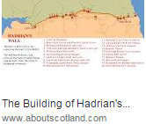
At the time,Hadrian's wall was simply intended to keep out raiders from the north. But it also marked the border between the two later countries, England and Scotland. Eventually, the border was established a few miles further north. Efforts to change it in later centuries did not succeed , mainly because on either side of the border an invading army found its supply line overstretched. A natural point of balance had been found. Roman control of Britain came to an end as the empire began to collapse. The first signs were the attacks by Celts of Caledonia in AD 367. The Roman legions found it more and more difficult to stop the raiders from crossing Hadrian 's wall. The same was happening on the European mainland as I The foundation stones Germanic groups, Saxons and Franks, began to raid the coast of Gaul, In A D 409 Rome pulled its last soldiers out of Britain and the Romano-British, the Romanised Celts, were left to fight alone against the Scots, the Irish and Saxon raiders from Germany. The following year Rome itself fell to raiders.
Exercise One :Read the text and answer the following :
I- Say true or false
1- The Roman invasion took place because the Celts of Britain were working with the Celts of Gaul.
2- The first Roman general to invade Britain was Julius Caesar
3- The Romans brought the skills of reading and writing to Britain
4- the Celtic tribes fought among themselves,this helped much the Romans to conquer Britain.
5- The Romans underminded the Celts’madness for war .
6-The Romans could not spread their culture throughout Britain because of Celtic resistance.
II- Match statements from column A with statements in column B
1- "Pretani "was | a- bHalted the Romans invasion of Britain
2- The Celts of Britain | b- The name given by Romans to the inhabitants of Britain
3- Hadrian's wall | c- Turned Britain to big food producer and exporter
4- Britain’s mild climate | d- Kept out raiders from the North
5- Boadicea's revolt | e- sheltered the Celts of Gaul from the Romans’attacks

III : Find definitions for the following words
1- peasantry 2- dwellers 3- war-mad 4- overstretched 5- raiders
Word | Definition
1- peasantry
2- dwellers
3- war-mad
4- overstretched
5- raiders

