Departement of te English Language
Module:Civilisation
Level:l 1
Time Alloted:1:30
TeacherProf.
RAOUTI Rabha
Title of Lesson: The Celts
Semester 1

Aims:
- Introduce Celtic History: Provide a foundational understanding of the Celts, their society, and their cultural practices during the Iron Age.
- Highlight Celtic Contributions: Showcase the Celts' advancements in warfare, governance, and social organization.
- Explore Gender Roles: Emphasize the unique role and independence of women in Celtic society.
- Encourage Appreciation of Heritage: Foster interest in the historical and cultural significance of the Celtic era in Britain and Europe.

Objectives:
- Identify Celtic Origins: Explain who the Celts were and where they settled in Britain and Europe.
- Describe Daily Life: Outline their farming practices, housing styles, and tribal governance.
- Examine Religious Practices: Discuss the role of Druids, their teachings, and rituals in Celtic society.
- Detail Military Practices: Highlight the Celts' use of weapons, their battle customs, and the symbolism of woad.
- Acknowledge Women's Roles: Illustrate the leadership and independence of Celtic women through examples like Boadicea.
- Discuss Roman Conflict: Explain the Celts’ resistance to Roman invasion and the legacy of their leaders.
This text aims to give readers an understanding of the Celts’ societal structure, cultural practices, and historical significance, particularly in Britain.

Unit 2 The Celts
The Celts were the pre-Roman people who lived in the Northwest of Europe and Britain during the Iron Age around 600 BC to 43 AD. An advanced society, they learned how to make weapons from iron, because of this, many know this era in time as the 'Iron Age'. Throughout Britain, the Celts settled in Cornwall and Wales Mostly.
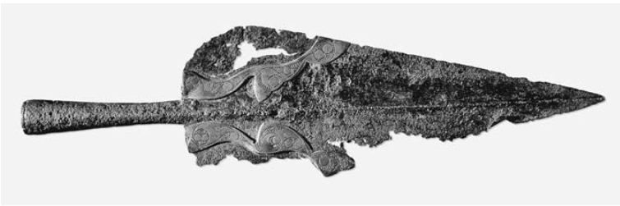
The spear, which economized on the use of metal, was a popular Celtic weapon. )© British Museum/Art Resource, NY)
There were three main factions of Celts in Europe, these included Brythonic, Gaulic and Gaelic. The main Celts who settled in Britain were the Brythonic branch. Once settled, like the Celts who arrived in England, they would split into many different tribes. Each tribe would be ruled by a king or queen. Most Celts were farmers and lived in houses that were round instead of square like we know today.
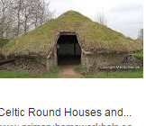

The Celtic tribes were ruled over by a warrior class, of which the priests, or Druids, seem to have been particularly important members. These Druids could not read or write, but they memorised all the religious teachings, the tribal laws, history, medicine and other knowledge necessary in Celtic society. The Druids from different tribes all over Britain probably met once a year. They had no temples, but they met in sacred groves of trees, on certain hills, by rivers or by river sources. We know little of their kind of worship except that at times it included human sacrifice.
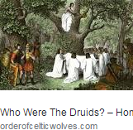
Celtic armies also included cavalry, mounted on ponies, and infantry. One custom for which their warriors became well known was painting themselves blue, using a substance known as woad, before going into battle.
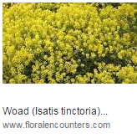
The reason for this is not clear, but it may have had something to do with the display of individual valor. Upper-class British men also made a point of displaying personal courage through hunting, although of course much hunting was carried out primarily for meat.
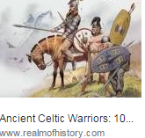

During the Celtic period women may have had more independence than they had again for hundreds of years. When the Romans invaded Britain two of the largest tribes were ruled by women who fought from their chariots. The most powerful Celt to stand up to the Romans was a woman, Boadicea. She had become queen of her tribe when her husband had died. She was tall, with long red hair, and had a frightening appearance. In AD 61 she led her tribe against the Romans. She nearly drove them from Britain, and she destroyed London, the Roman capital, before she was defeated and killed.
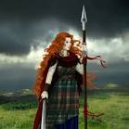https://www.google.com/url?q=https://www.facebook.com/pages/category/Book-Series/Boudica-the-Red-
Exercise One: Read the text and answer the following :
I- Say true or false and correct the mistakes if found
1- The Celts were the post-Roman people who lived in the Northwest of Europe and Britain during the stone Age.
2- The Celts were backward and unskilled people.
3- The Celts’ main settlements were in Cornwall and Ireland.
4- The main Celts who settled in Britain were of Gaulic descent.
5- The Celtic tribes were under the direct rule of wealthy classes.
6-Although illiterate Druids mastered almost all types of knowledge through memorisation
II- Complete the following sentences
1- The warrior class includes………………..and………………..
2- According to some researchers, Druids came to meet ……………..from all over Britain in…………………..or in………. …
3- …………………… was a kind of Celts’ worship.
4- The Celtic warriors used to …………………… in ………using……….. before
going to battle.
5- Hunting was the most prominent practice of the ……………………………
6- Celtic Women enjoyed …………………… than for hundered of years to come.
7- …………………. was the most powerful Celt who stood to the Romans.

III- Give the definitions for each of bthe following :
1- priests 2- temples 5- infantry
3- custom 4- ponies
V : Answer the the following questions using your own words.
1- Why was Iron Age called so ?
…………………………………………………………………………………………………………………………………………………………………………………………
2- Name the main factions of Celtic tribes ?
………………………………………………………….………………………………………………………….……………………………………………………………..
3- Who were the Druids.
………………………………………………………………………………………………………………………………………………………………………………………………………
4- What did hunting symbolise in Celtic traditions ?
………………………………………………………………………………………………………………………………………………………………………………………………………………….
5- Illustrate for the special role the Celtic women played in fighting the Romans ?
……………………………………………………………………………………………………………………………………………………………………………………………………………………

VI : Homework : Using the information in previous activities to summarise the text in no more than 15 lines.
……………………………………………………………………………………………………………………………………………………………………………………………………………………………………………………………………………………………………………………………………………………………………………………………………………………………………………………………………………………………………………………………………………………………………………………………………………………………………………………………………………………………………………………………………………………………………………………………………………………………………………………………………………………………………………………………………………………………………………………………………………………………………………………………………………………………………………………………………………………………………………………………………………………………………………………………………………………………………………………………………………………………………………………………………………………………………………………………………………………………………………………………………………………………………………………………………………………………………………………………………………………………………………………………………………………………………………………………………………………………………………………………………………………………………………………………………………………………………………………………………………………………………………………………………………………………………………………………………………………………………………………………………………………………………………………

